THE RED ROSARY OF HOPE- 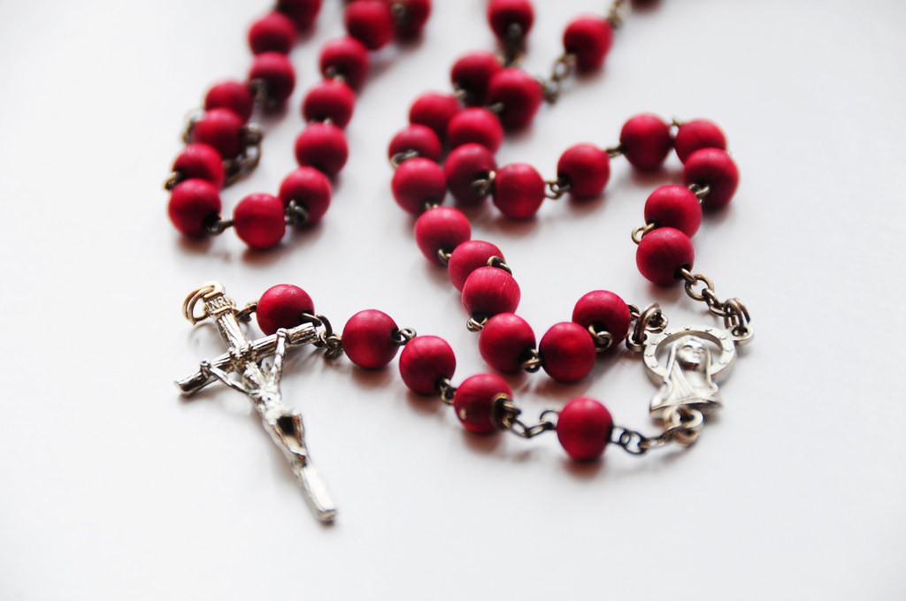
A ministry dedicated to Our Lady of Hope to empower the elderly and the suffering to unite their suffering to the Cross of Our Lord for the good of their souls and those whom they love.
SUFFERING—a word most of us would rather not think about. A word that culture teaches is best to put an end to as quickly as possible. +On the contrary, suffering is a Grace.— + Suffering reminds us that this world is not our rest, and to call our thoughts upwards where our true treasure is- —and where our heart ought to be. When we unite our sufferings to Christ then we begin to take our earthly journey heavenward. + ____________________________________
Our beloved Saint Pope John Paul II stated: “ ….the Passion of Christ on the cross gave a radically new meaning to suffering, transforming it from within. [Jesus] introduced into human history, which is the history of sin, a blameless suffering accepted purely for love. All human suffering, all pain, all infirmity contains within itself a promise of salvation, a promise of joy,” _________________________________
Yet, suffering remains a mystery. In Christ lies the clue to the mystery of suffering. And this mystery brings with it Grace. The Grace to enter into the mystery and to receive the blessings it carries. +
+ We ask for the patience to accept the bitter-sweet medicine of suffering described by
St. Jean Eudes three centuries ago: + “ You can advance farther in grace in one hour during this time of affliction than in many days during a time of consolation.” +

First Letter of Saint Peter 4 : 12-13 “Beloved, do not be surprised that a trial by fire is occurring among you, as if something strange were happening to you. But rejoice to the extent that you share in the sufferings of Christ, so that when His glory is revealed you may also rejoice exultantly.” + + + Do not deny the POWER of your suffering. When you unite your suffering to the Cross of Our Lord + it becomes redemptive suffering for the good of your soul and for souls of others. + + + The exact point where humanity comes in touch with divinity— is the + CROSS +
The Cross is a positive + sign in our life, not a negative one.
To unite your suffering with Christ is to grow in the likeness of God.
The battle for our soul is analogous to the darkest hours of the Franco-Prussian War. It was at this time that Our Lady of Pontmain appeared in the night sky with a message of HOPE.
It is at these dark, suffering times in our lives that we are to call upon Our Lady of Hope and recite + The Red Rosary of Hope. + Through prayer we are called to unite our suffering with the Passion of Our Lord and enter into the mystery and the power of the Cross. Through prayer we are invited to unite our suffering to Christ in reparation of our sins and those of the whole world.

But Pray My Children, God will Hear You In a Short Time..My Son Permits Himself to Be Moved….” Our Lady of Hope of Pontmain (1/17/1871)
In her hands was a blood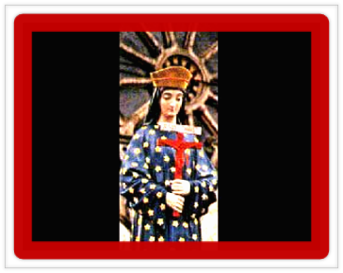 red crucifix.
This image is of Our Lady of Hope of Pontmain. She is the inspiration behind the Red Rosary of Hope. Her apparition was seen on January 17, 1871. This date marked the darkest hour of the Franco-Prussian War (when 2/3 of the country of France was in the hands of the Germans). It was also at this time that the laity had taken the initiative in France to consecrate themselves to the Sacred Heart of Jesus and the Immaculate Heart of Mary. The German armies were gathering ready to invade the west of France. The people too gathered in prayer. Our Lady of Hope appeared in the sky at Pontmain, a short distance from where the German armies were gathering. In her hands was a blood red crucifix. A band appeared at her feet with the words: “But Pray My Children, God will Hear You In a Short Time... My Son Permits Himself to Be Moved….” The Holy Virgin Mary lit up the sky of Pontmain for 3 hours in front of a few children. She increased in size during the recitation of the Rosary. She is the Virgin who smiled and accompanied the singing of the people with the movement of her hands. She is the Virgin whose head was framed by 3 bright stars that were visible to all—indicating her union with the Blessed Trinity.
It is recorded that the enemy armies did not take a single further step towards the west of France. The next day they were 12 miles back. The Peace Treaty was signed 6 days later, and the war ended. All 38 men from that town returned safely home. ~ ~ ~
Suffering has meaning. Do not deny the power of that suffering but instead unite it to Our Lord. The cross is not misery. Praise God that you are counted worthy to suffer with Christ. Because when you suffer with Him you will also be glorified with Him in heaven.
NIHIL OBSTAT June 7, 2018
IMPRIMATUR : June 13, 2018 Most Reverend Charles J. Chaput, OFM Cap
For additional rosaries/brochures email: Red Rosary of Hope at:
redrosaryofhope@gmail.com
THE RED ROSARY OF HOPE: Reparation
SuffEring
ReDemption ROSARY

